Richard Sobel
Policy Analyst
Privacy and Confidentiality
Public Opinion and Foreign Relations
Bio:
Richard Sobel explores the relationships between citizens and governments as a Senior Research Associate in the Program in Psychiatry and the Law at Harvard Medical School, and a Senior Research Associate at the Roper Center for Public Opinion Research at the University of Connecticut in Storrs. His work includes the policy analysis of privacy and confidentiality issues, particularly on constitutional and political questions about governmental databanks and identification schemes. It also explores the influence of public opinion on foreign policy in the U.S. and abroad. The privacy and foreign policy strands became more closely allied in the post-911 era of concerns for how international issues like anti-terrorism affect the domestic realm, including civil liberties.
Previously, he was a Fellow at the Berkman Center on Internet and Society at Harvard Law School and a Fellow at the Shorenstein Center on Press, Politics and Public Policy at the Kennedy School of Government. In teaching at Princeton University, Smith College, the University of Connecticut, and Harvard University, his courses include public policy analysis, the social consequences of technology, social movements, and public opinion in foreign policy. He is a former board member of the Eastern Connecticut Civil Liberties Union, a founder and director of the Cyber Privacy Project, and a member of the Massachusetts Civil Liberties Union Technology and Privacy Committee. He is also a member of the New York Times College Program Advisory Board, the Chicago Council on Foreign Relations (CCFR), and the American Political Science Association. He has been a consultant on public opinion to the New York Times/CBS poll, the Chicago Council on Foreign Relations study of American Public Opinion and U.S. Foreign Policy, and organizations concerned with privacy and medical confidentiality.
His work and comments on privacy, confidentiality, and public and foreign policies have appeared in the Boston Globe, Chicago Tribune, Christian Science Monitor, Los Angeles Times, New York Times, Newsday, USA Today, Time International and Washington Post. He has been interviewed on privacy, confidentiality, citizenship, immigration, and foreign affairs issues on NPR, WGN, CNN and CBS radio affiliates and on WGBH and Global TV. He has spoken on topics including "The Bill of Rights," "National Identity Cards," "HIPAA, Medical Confidentiality, and Consent" and "The Impact of Public Opinion on Foreign Policy." Recently he keynoted "The Conference on International Information Policy and E-Society" at National Cheng Chi University. A native of Chicago, Sobel received a bachelors degree from Princeton University and a doctorate from the University of Massachusetts, Amherst.

Sobel’s books include:
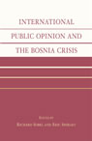
- International Public Opinion and the Bosnia Crisis (with Eric Shiraev; Lexington, 2003)

- The Impact of Public Opinion on U.S. Foreign Policy Since Vietnam: Constraining the Colossus (Oxford, 2001).
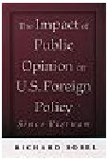

- Public Opinion in U.S. Foreign Policy: The Controversy Over Contra Aid (Rowman & Littlefield, 1993)
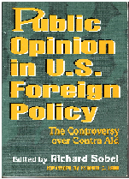

- The White Collar Working Class (Praeger, 1989).
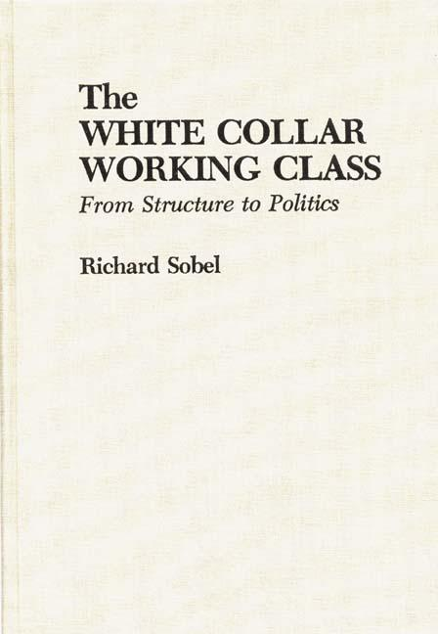

- People and Their Opinions: Thinking Critically about Public Opinion, (with Eric Shiraev, is forthcoming Longman,)
